AI-powered classification of the diabetic retinopathy severity

Prepared by
Thanh Thao Nguyen (nguyen53661@saskpolytech.ca)

Under the guidance of
The Artificial Intelligence and Data Analytics Program

Submitted to
Himanshu Patel (patelh@saskpolytech.ca)

Saskatchewan Polytechnic


CAPSTONE PROJECT REPORT
DECEMBER 2025
ABSTRACT
This project aims to develop a deep learning model for diabetic retinopathy severity classification using EfficientNetV2B3. The model processes high-resolution retinal images to classify diabetic retinopathy accurately. By leveraging advanced convolutional techniques such as atrous convolutions, the model achieves high precision in diabetic retinopathy severity classification, with an accuracy of 81.45% and a loss of 51.68%. The dataset used is sourced from Kaggle's Diabetic Retinopathy 224x224 (2019 Data) dataset, containing 3,663 images and their corresponding masks. The report details the methodology, data preprocessing steps, model training, evaluation, and comparisons between EfficientNetB0, ResNet50, DenseNet121, and Vision Transformer ViT-Ti/16.

ACKNOWLEDGEMENT
We extend our gratitude to our faculty mentor, Himanshu Patel, for the guidance and support throughout this project. We also thank Saskatchewan Polytechnic for providing the necessary resources and infrastructure for our research. Finally, we appreciate the contributions of online communities, particularly Kaggle, for dataset availability and valuable insights.

Contents
I. INTRODUCTION 6
II. PROJECT OVERVIEW 6
III. PROBLEM STATEMENT 7
IV. PROJECT OBJECTIVE 7
V. RELATED WORK 7
VI. METHODOLOGY 8
1. Data Collection 8
2. Data Preprocessing 8
a. Image Resizing 8
b. Data Normalization 8
c. Data Augmentation 9
3. Model Development 9
a. Architecture 9
b. Optimizer 10
c. Metrics 10
d. Framework and Environment 10
VII. RESULT AND ANALYSIS 10
1. The Accuracy and Loss of Training and Validation Comparison 10
2. Test Accuracy and Confidence Score Comparison 12
3. Model Preference 13
VIII. ENHANCEMENT 13
1. Enhancement Overview 13
a. Increased training epochs 13
b. Reduce learning rate 13
2. Result and Enhancement 14
a. Test Accuracy 14
b. Overall accuracy 15
IX. CONCLUSION 15
X. SCOPE OF FUTURE WORK 16
1. Expand the dataset for greater diversity 16
2. Deploy the model on a website 16
3. Integrate into the telemedicine system 16
XI. REFERENCES 16

INTRODUCTION
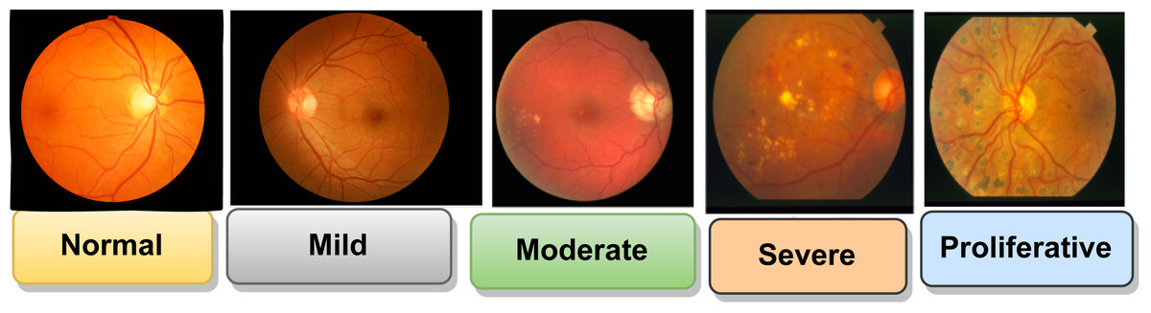
The severity of Diabetic Retinopathy ranges from Normal to Proliferative

With the rise of artificial intelligence and deep learning in health care applications, rapid and accurate diabetic retinopathy classification via retinal images has become a crucial task for personal treatment planning, patients’ physical and mental health care, and cost-saving. Traditional methods for diabetic retinopathy classification often struggle with the complexity of the disease, the ability of doctors, and the personal situation of each patient.

This project investigates the use of EfficientNetV2B3, a state-of-the-art convolutional neural network architecture, for enhancing diabetic retinopathy severity classification accuracy in supporting the detection and treatment of diabetic retinopathy.

PROJECT OVERVIEW
This project presents a deep learning approach to diabetic retinopathy classification using EfficientNetV2B3. The model is evaluated in comparison with EfficientNetB0, ResNet50, DenseNet121, and Vision Transformer ViT-Ti/16. Key objectives include:
• Leveraging EfficientNetV2B3’s architecture to accurately classify diabetic retinopathy.
• Assessing model performance using the Accuracy of the Confusion Matrix.
• Benchmarking against other models to determine model effectiveness.
• Exploring applications in real-world medical tasks.

PROBLEM STATEMENT
Accurately classifying diabetic retinopathy from retinal imagery remains a non-trivial task due to challenges such as:
• The misclassification of retinal images.
• The personal situation of each patient.
• Varying resolution and illumination conditions.
• Traditional classification based on doctors is time-consuming.

Hence, there is a pressing need for an automated, deep learning-powered solution to streamline diabetic retinopathy classification.

PROJECT OBJECTIVE
The main objectives of this project are:
• Implement EfficientNetV2B3 to classify diabetic retinopathy from retinal imagery with high accuracy.
• Optimize input data through preprocessing and augmentation.
• Compare EfficientNetV2B3 with EfficientNetB0, ResNet50, DenseNet121, and Vision Transformer ViT-Ti/16 under controlled conditions.
• Evaluate performance using the Accuracy of the Confusion Matrix.
• Generate reliable, generalizable classification results for practical use.

RELATED WORK
Previous research in diabetic retinopathy classification applies a computer vision technique and a deep learning model named EyeArt (owned by the company named Eyenuk, Inc.). The limitation of this model is misclassifying “healthy” eyes as “diabetic retinopathy” eyes - misclassification. The EfficientNetV2B3 model improves classification accuracy and avoids misclassification.

METHODOLOGY

Data Collection
Dataset link: Diabetic Retinopathy 224x224 (2019 Data)

The dataset used for this project comprises high-resolution retinal images with corresponding retinal masks from Kaggle's Diabetic Retinopathy 224x224 (2019 Data), with 3,663 high-resolution retinal images and their corresponding retinal masks. The images capture the five classes of diabetic retinopathy: Severe (193 images), Proliferative Diabetic Retinopathy (295 images), Mild (370 images), Moderate (999 images), and No Diabetic Retinopathy (1805 images).

Each image in the dataset is paired with a label, where retinal pixels are labeled for training supervised classification models. Data augmentation techniques such as rotation, flipping, zoom, and contrast adjustment were applied to enhance model generalization and prevent overfitting.

Data Preprocessing

Image Resizing
Retinal images often come in high resolutions, which may not be optimal for training deep learning models due to GPU memory limitations. All images and corresponding masks were resized to a fixed resolution of 224×224 pixels. This allowed for:
• Uniform input dimensions for the model.
• Reduced computational cost during training.
• Preservation of essential spatial features despite the down-sampling.

Data Normalization
The pixel values of the images were scaled from the original range (0-255) to a [0, 1] range using min-max normalization with the function “custom_normalize_to_neg1_pos1.” Unfortunately, after normalization, the Test Accuracy is only 66.03%.
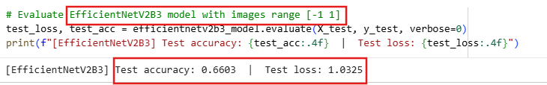
Then, the pixel values of the images remain in the original range (0-255). It is flexible to train five different models with one dataset.

Data Augmentation
Since retinal pixels are often underrepresented in the image compared to background pixels (data imbalance), augmentation was used to artificially increase the training dataset and improve model generalization. Techniques used include:
• Random flip (Horizontal) – simulate retinal orientations.
• Random rotation (from -9° to 9°) – account for angled views.
• Random zoom (10%) – zoom in or zoom out images.
• Contrast adjustment (10%) – mimic different lighting conditions.

All augmentation was applied to both the input image and its corresponding mask, ensuring label integrity during transformation.

Model Development

Architecture
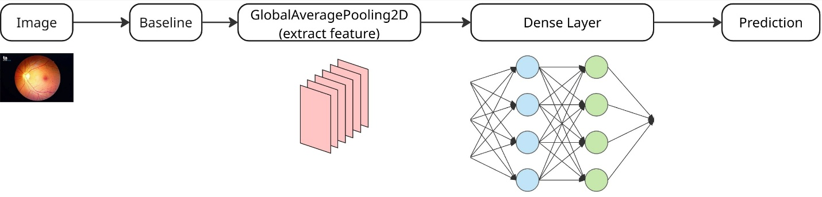
- Baseline: base_efficientnetv2b3_model (pre-trained model on ImageNet)
- GlobalAveragePooling2D is used to extract rich hierarchical features from input images.
- Dense Layers (Hidden Layers) study the features of images.
- Prediction (Output Layers) uses the activation function “softmax” to calculate the probability of a class over the total number of classes and helps the model to predict the result.

Optimizer
The Adam optimizer was used to update the model weights efficiently, with the Learning Rate is 0.0010 (fine-tune stage) (carefully chosen to ensure steady convergence over a few epochs).

Metrics
The Test Accuracy was used for performance evaluation and comparison.

Framework and Environment
• Framework: Implemented using Keras due to its modular design and community support for custom classification models.
• Platform: Training was conducted in Kaggle with GPU support (L4 GPU), offering accelerated computation within resource limitations.

RESULT AND ANALYSIS

The Accuracy and Loss of Training and Validation Comparison
EfficientNetB0
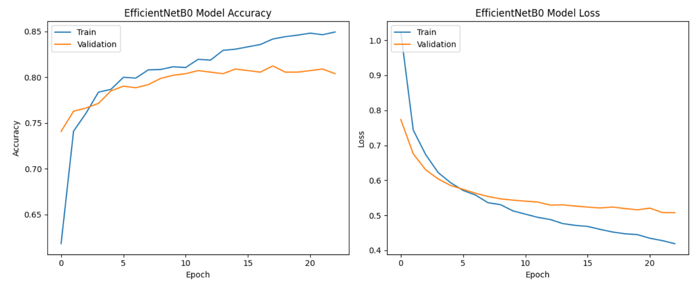
EfficientNetV2B3
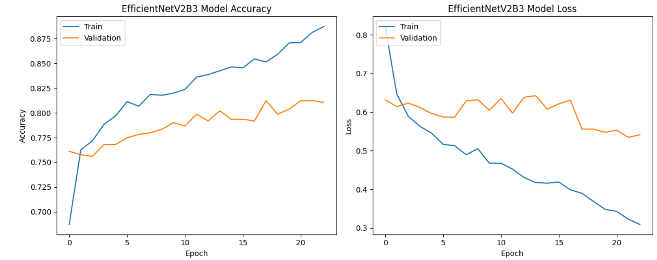
ResNet50
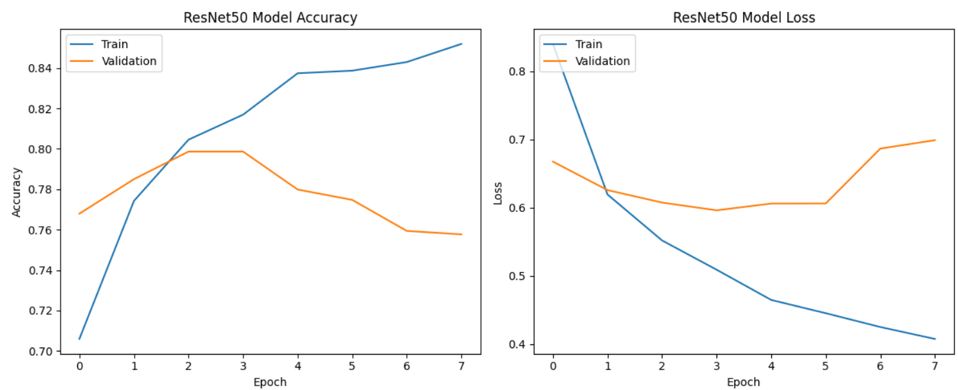
DenseNet121
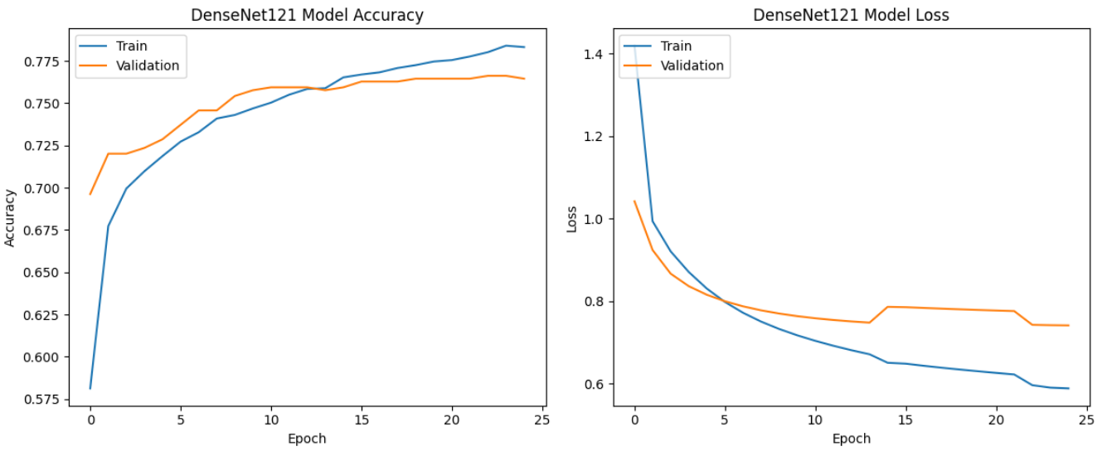
Vision Transformer ViT-Ti/16
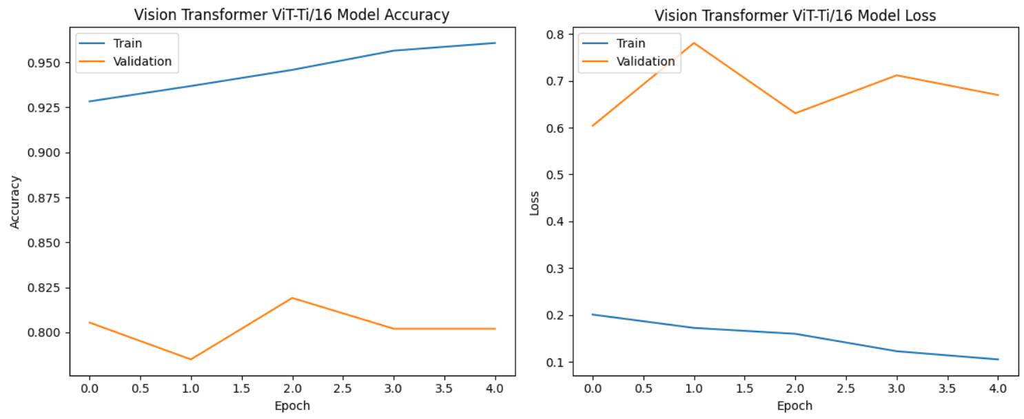
Based on the above graphs, the EfficientNetB0, EfficientNetV2B3, and DenseNet121 can be selected. Next, we need to evaluate via Test Accuracy and Confidence Score.

Test Accuracy and Confidence Score Comparison
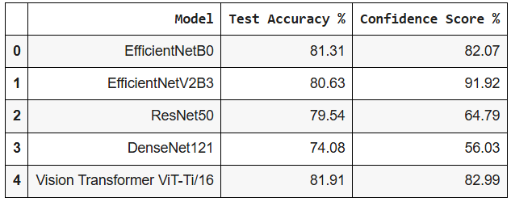

EfficientNetB0 is chosen with the highest accuracy, 81.31% at the beginning, but Test Accuracy reduces to 78.04% after fine-tuning.

ResNet50 and DenseNet121 models misclassification. The image belongs to class 1 (Mild Diabetes), but models predict class 0 (No Diabetes).

Vision Transformer ViT-Ti/16 model is misclassification. The image belongs to class 1 (Mild Diabetes), but models predict class 2 (Moderate Diabetes).
EfficientNetV2B3 is the second choice for fine-tuning with a Test Accuracy of 80.63%.

Model Preference
Vision Transformer ViT-Ti/16: If you need a model with high Test Accuracy, you can pick this model. The condition is that a good platform is necessary.

EfficientNetV2B3 matches with a moderate platform and a small dataset. This model is also flexible to adjust.

ENHANCEMENT

Enhancement Overview
To improve the performance of the segmentation model, the following enhancement steps were implemented:

Increased training epochs
The training epochs are increasing from 25 to 50. The model has a longer time for training.
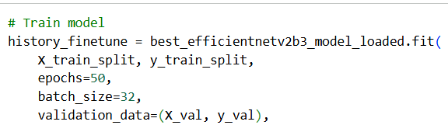

Reduce learning rate
Learning rate reduces from 0.0010 to 0.0001 with the minimum learning rate = 0.00000001.
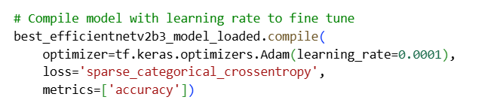
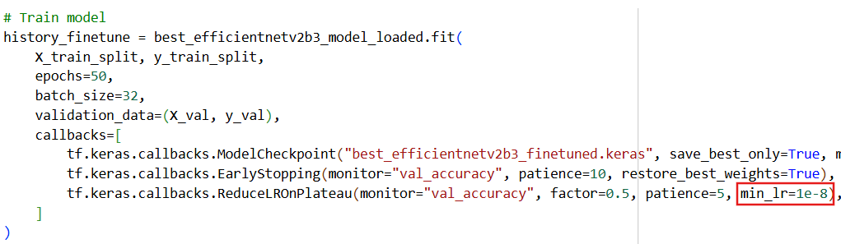

Result and Enhancement

Test Accuracy
EfficientNetB0: reduce from 81.31% to 78.04% and 74.76%.

EfficientNetV2B3: reduce from 80.63% to 73.81% and increase to 79.95% and 81.45%.

ResNet50: increase from 77.90% to 79.54% but still predicts the class wrongly.

DenseNet121: stay on 74.08% (not evaluate more when the model predicts the wrong class)

Vision Transformer ViT-Ti/16: increase from 80.20% to 81.91% but still predicts the class wrongly.

Overall accuracy
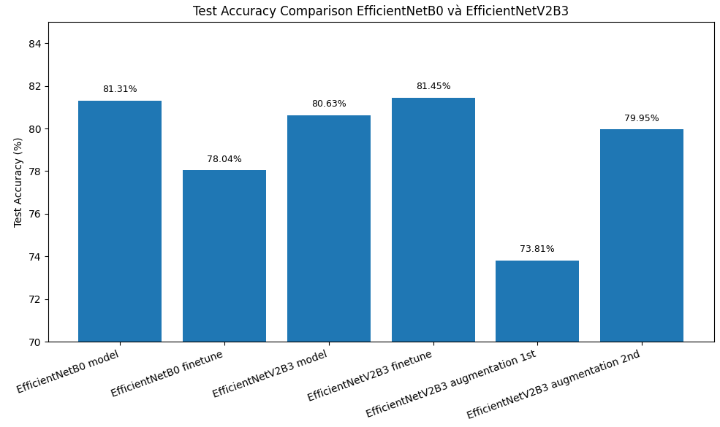
Based on the above graph, the Test Accuracy of EfficientNetV2B3 is the highest (81.45%).

CONCLUSION
This project successfully implemented EfficientNetV2B3 for diabetic retinopathy classification, with further enhancements leading to notable improvements in performance. By reducing the learning rate and increasing the number of training epochs from 25 to 50, the model achieved a higher Accuracy score of 81.45% on the test set.

These enhancements not only improved the model's classification accuracy and precision but also demonstrated its strong generalization ability across validation and test datasets. Compared to previous results and alternative models such as EfficientNetB0, ResNet50, DenseNet121 and Vision Transformer ViT-Ti/16, EfficientNetV2B3 continues to outperform in both accuracy and efficiency, confirming its viability as a robust solution for automated road extraction in satellite imagery.

SCOPE OF FUTURE WORK
While this project has demonstrated the effectiveness of EfficientNetV2B3 in diabetic retinopathy classification from retinal imagery, several areas remain open for further exploration and enhancement:

Expand the dataset for greater diversity
The current dataset, while effective for experimentation, could be expanded to include more images of other diseases, such as Cataract and Glaucoma. The model can detect other eye diseases while it classifies diabetic retinopathy. A more diverse dataset would improve the model’s generalization and adaptability in real-world applications.

Deploy the model on a website
Building an interactive interface (e.g., using Streamlit) would allow doctors to upload retinal images and receive classification results in real-time, increasing productivity in classifying disease and early treatment.

Integrate into the telemedicine system
In the countryside, there are small hospitals and no ophthalmologists. The patient can take photographs of their retina at a facility near their home. AI can help to classify it. When doctors see “no diabetic retinopathy”, they can focus on more severe cases.

REFERENCES
The severity of Diabetic Retinopathy ranges from Normal to Proliferative. From Stages of DR [Photograph], by Prasanna Porwal, Samiksha Pachade, Ravi Kamble, Manesh Kokare, Girish Deshmukh, Vivek Sahasrabuddhe, Fabrice Meriaudeau, April 24, 2018, “Indian Diabetic Retinopathy Image Dataset (IDRiD)”, IEEE Dataport, https://dx.doi.org/10.21227/H25W98, (https://peerj.com/articles/cs-1947/). CC BY 4.0 DEED.

Jennifer Irene Lim, Carl D Regillo, SriniVas R Sadda, Eli Ipp, Malavika Bhaskaranand, Chaithanya Ramachandra, Kaushal Solanki (30th September 2022), Artificial Intelligence Detection of Diabetic Retinopathy. Ophthalmol Sci, 3(1):100228. https://pmc.ncbi.nlm.nih.gov/articles/PMC9636573/

